CYBERSECURITY INTERNSHIP
Organization name: Elevate labs

Student Name: Kemisetti Bhima Sai Sundar
University: Aditya University
Domain: Cybersecurity
Duration: 1st January 2026 to 30th April 2026

TASK-6: Introduction to Cryptography

1. Overview
Cryptography is the practice and study of techniques used to secure communication and data in the presence of adversaries. It plays a critical role in modern digital systems by ensuring data confidentiality, integrity, authentication, and non-repudiation. With the rapid growth of the internet and digital transactions, cryptography has become essential for protecting sensitive information.

2. Objectives of Cryptography
The main objectives of cryptography are:
- Confidentiality: Ensuring that information is accessible only to authorized users.
- Integrity: Protecting data from unauthorized modification.
- Authentication: Verifying the identity of users and systems.
- Non-Repudiation: Preventing denial of actions such as sending a message or completing a transaction.

3. Basic Cryptographic Terminology
- Plaintext: Original readable data.
- Ciphertext: Encrypted data that appears unreadable.
- Encryption: The process of converting plaintext into ciphertext.
- Decryption: The process of converting ciphertext back into plaintext.
- Key: A secret value used in encryption and decryption.
- Algorithm (Cipher): A mathematical procedure used for encryption.

4. Types of Cryptography
1. Symmetric Key Cryptography
In symmetric cryptography, the same key is used for both encryption and decryption. It is fast and suitable for large amounts of data but requires secure key sharing.
Examples:
- AES (Advanced Encryption Standard)
- DES (Data Encryption Standard – obsolete)

2. Asymmetric Key Cryptography
Asymmetric cryptography uses two keys: a public key and a private key. The public key is shared openly, while the private key is kept secret.
Examples:
- RSA
- Elliptic Curve Cryptography (ECC)

3. Hash Functions
Hash functions convert data into a fixed-length hash value. They are one-way functions and are mainly used for data integrity and password storage.
Examples:
- SHA-256
- SHA-3


Step-1: check the openssl version


Step 2 :- Create a Sample File
create a sample file of the choice

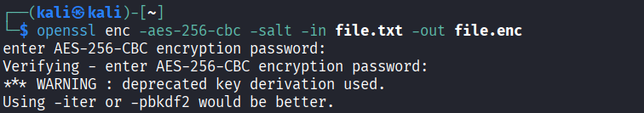
Step 3 :- Encrypt File Using AES-256

Step 4 :- Verify Encrypted File

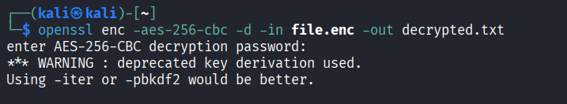
Step 5 :- Decrypt the AES Encrypted File

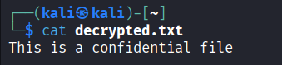
Step 6: - Confirm DecryptionGenerate RSA keys :-

- Generate RSA keys:
RSA is an asymmetric encryption algorithm based on the mathematical difficulty of factoring large prime numbers.
- The private key is used for decryption or signing
- The public key is used for encryption or verification
RSA is commonly used for secure key exchange, authentication, and digital signatures.
  - Generate a 2048-bit RSA private key



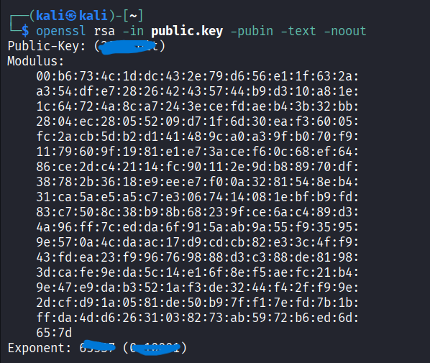
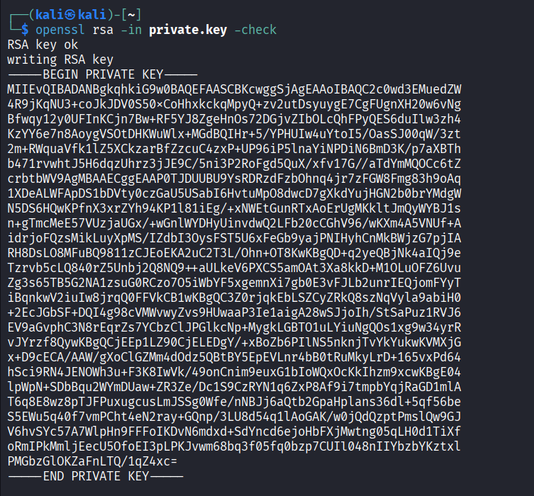


- Understand digital signatures:
A digital signature ensures:
- Authentication – verifies sender identity
- Integrity – ensures data is not altered
- Non-repudiation – sender cannot deny sending data
Digital signatures work using hashing + asymmetric cryptography:
- Message is hashed
- Hash is encrypted using sender’s private key
- Receiver decrypts using public key and verifies hash

- Hash files and verify integrity:

A hash function converts data into a fixed-length value called a hash or message digest.
Properties:
- One-way function
- Small input change causes big hash change
- Used for integrity.

Examples:
MD5 (weak), SHA-1 (deprecated), SHA-256 (secure)

- Generate hash:

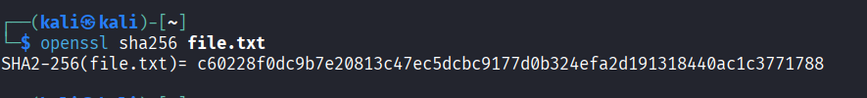


- Check for integrity:

The hashes are been matched .

- Compare encryption algorithms:

Encryption algorithms are used to secure data by transforming it into an unreadable form, and they are broadly classified into symmetric and asymmetric encryption methods.

AES (Advanced Encryption Standard) is a symmetric algorithm and is the most widely used today because it provides strong security, high speed, and efficiency, making it suitable for encrypting large volumes of data such as files, disks, and network traffic.

DES (Data Encryption Standard) is an older symmetric algorithm that uses a small key size and is now considered insecure, while 3DES (Triple DES) improves security by applying DES three times but suffers from slow performance and is gradually being replaced by modern algorithms.

RSA is an asymmetric encryption algorithm that uses a pair of public and private keys and is mainly used for secure key exchange, authentication, and digital signatures, although it is slower and not ideal for encrypting large data.

ECC (Elliptic Curve Cryptography) is a modern asymmetric approach that offers the same or higher level of security as RSA with much smaller key sizes, making it efficient for mobile devices, IoT systems, and modern secure communications.

In practice, most secure systems use hybrid encryption, where asymmetric algorithms like RSA or ECC are used to securely exchange keys, and symmetric algorithms like AES are used for fast and secure data encryption.

- Real-world usage (HTTPS, VPN):

In HTTPS (Hypertext Transfer Protocol Secure), cryptography is used to protect data exchanged between a user’s browser and a web server. When a secure connection is established, asymmetric encryption (such as RSA or ECC) is first used to authenticate the server and securely exchange a session key. Once this process is complete, symmetric encryption algorithms like AES are used to encrypt the actual data transfer because they are faster and more efficient. This ensures confidentiality, integrity, and authentication, preventing attacks such as eavesdropping, data tampering, and man-in-the-middle attacks.

VPN (Virtual Private Network) technology, cryptography is used to create a secure tunnel over an untrusted public network like the internet. VPNs use strong symmetric encryption algorithms (commonly AES) to encrypt all data packets transmitted between the user and the VPN server. Asymmetric encryption and digital certificates are often used during the initial connection phase for authentication and secure key exchange. This allows users to safely access private networks remotely, protect sensitive data, and maintain privacy even when using public Wi-Fi networks.

- Findings:
During this cryptography experiment:
- I learned symmetric and asymmetric encryption concepts
- I performed AES encryption and RSA key generation
- I verified data integrity using hashing
- I understood how digital signatures work
- I explored real-world cryptographic applications

